New Valve Materials for Heavy-Duty Engines Meet the Challenges of Downsizing
Federal-Mogul Powertrain expands range with cost-effective, high performance alloys

Friedberg, Germany, 28 June 2016 … Federal-Mogul Powertrain, a division of Federal-Mogul Holdings Corporation (NASDAQ: FDML) has introduced new materials for inlet and exhaust valves in response to the challenges of higher loads, increased intergranular and oxidation corrosion risk and continued downward cost pressure. The materials are the result of a ‘twin-track’ approach by the company to define both an upgrade to conventional austenitic steel and also a more cost-effective alternative to high nickel ‘superalloys’.
As in the light vehicle market, the quest for improved fuel economy is driving the trend of downsizing and boosting in heavy-duty diesel engines. Previous generations of 16 litre engines have been replaced by 12 and 13 litre units, with even 10 or 11 litre engines now producing 500 hp. This has led to a requirement for valves with increased high temperature strength that can withstand combustion pressures of 220 bar and above, while at the same time emissions reduction strategies are increasing the levels of exhaust gas recirculation (EGR) exposing the valves to greater risk of wet corrosion.

“For demanding applications the conventional answer is a premium material such as Federal-Mogul Powertrain’s ECMS-Ni80A, but with a Nickel content greater than 70 percent this is not always an economic solution,” explained Gian Maria Olivetti, Chief Technology Officer, Federal-Mogul Powertrain. “We have established new ways to make more effective use of the expensive alloying elements such as Nickel by validating materials with equivalent hot strength to ECMS-Ni80A, but a lower alloy content.”
The main factors that differentiate the new materials in the range are the percentages of Nickel (Ni), Chrome (Cr) and Manganese (Mn) that they contain. One of the upgraded alloys, ECMS-2512NbN, is a development from standard CrMn austenitic steel designed to suit both inlet and exhaust applications experiencing elevated temperatures. By increasing the Nickel content from the usual 3 to around 12 percent while fine-tuning the combination of other elements in the alloy, both hot strength and corrosion resistance are significantly enhanced.
For higher temperature applications, ECMS-Ni36 high performance austenitic steel alloy has a superior resistance to hot oxidation than its industry standard equivalent, ECMS-3015D (austenitic steel with 15 percent Chromium and 31 percent Nickel). Additionally, despite having only 36 percent Nickel content, it has similar tensile strength to the superalloy, ECMS-Ni80A, which contains more than 70 percent Nickel.
The development and validation process for a new valve material, which can take up to 10 years, includes the identification of appropriate alloying elements and limits on composition as well as the subsequent effect on grain structure. Exhaustive internal validation by Federal-Mogul to prove suitability for future market challenges then follows.
“The very high level of alloying elements present makes these materials quite special,” commented Guido Bayard, Director, Global Valvetrain Technology, Federal-Mogul Powertrain. “In order to predict reliability and conformity to engine applications, a wide range of rig and laboratory tests on wear, corrosion and durability are conducted, with a series of engine application trials on dynamometers also completed.”
Federal-Mogul is already in series production with valves made from ECMS-2512NbN and ECMS-3015D, while ECMS-Ni36 valves are undergoing trials with customers ahead of further production launches. The alloys ECMS-2512NbN and ECMS-Ni36 are equally applicable to on-highway, off-highway and leisure marine applications in the 10-16 litre category; for heavy-duty applications where the requirements exceed even the capabilities of ECMS-Ni80A valves – for example some marine and CNG high output engines – Federal-Mogul provides valves with hollow stems that have enhanced heat dissipation performance.
To ensure the maximum efficiency and durability of its valves in service, Federal-Mogul also manufactures a wide range of associated components including retainers, cotters and valve rotators. These will be on show together with a selection of valves on Federal-Mogul Powertrain’s stand at IAA, Hannover from 21-29 September 2016. The company will exhibit at Booth C28 in Hall 13.

About Federal-Mogul
Federal-Mogul Holdings Corporation (NASDAQ: FDML) is a leading global supplier of products and services to the world’s manufacturers and servicers of vehicles and equipment in the automotive, light, medium and heavy-duty commercial, marine, rail, aerospace, power generation and industrial markets. The company’s products and services enable improved fuel economy, reduced emissions and enhanced vehicle safety.

Federal-Mogul operates two independent business divisions, each with a chief executive officer reporting to Federal-Mogul's Board of Directors.

Federal-Mogul Powertrain designs and manufactures original equipment powertrain components and systems protection products for automotive, heavy-duty, industrial and transport applications.

Federal-Mogul Motorparts sells and distributes a broad portfolio of products through more than 20 of the world’s most recognized brands in the global vehicle aftermarket, while also serving original equipment vehicle manufacturers with products including braking, wipers and a range of chassis components. The company’s aftermarket brands include ANCO® wiper blades; Champion® spark plugs, wipers and filters; AE®, Fel-Pro®, FP Diesel®, Goetze®, Glyco®, Nüral®, Payen® and Sealed Power® engine products; MOOG® chassis components; and Ferodo®, Jurid® and Wagner® brake products.

Federal-Mogul was founded in Detroit in 1899 and maintains its worldwide headquarters in Southfield, Michigan. The Company has more than 53,000 employees globally. For more information, please visit www.federalmogul.com.

###

CONTACT:
Paul Chadderton  Market Engineering  +44 (0)1295 277050  paul.chadderton@m-eng.com | Ursula Hellstern  Federal-Mogul Powertrain Communications  +49 (611) 201 9190  ursula.hellstern@federalmogul.com

IMAGES:
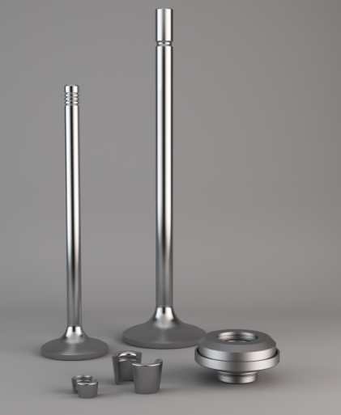 | To ensure the maximum efficiency and durability of its valves in service, Federal-Mogul also manufactures a wide range of associated components including retainers, cotters and valve rotators.
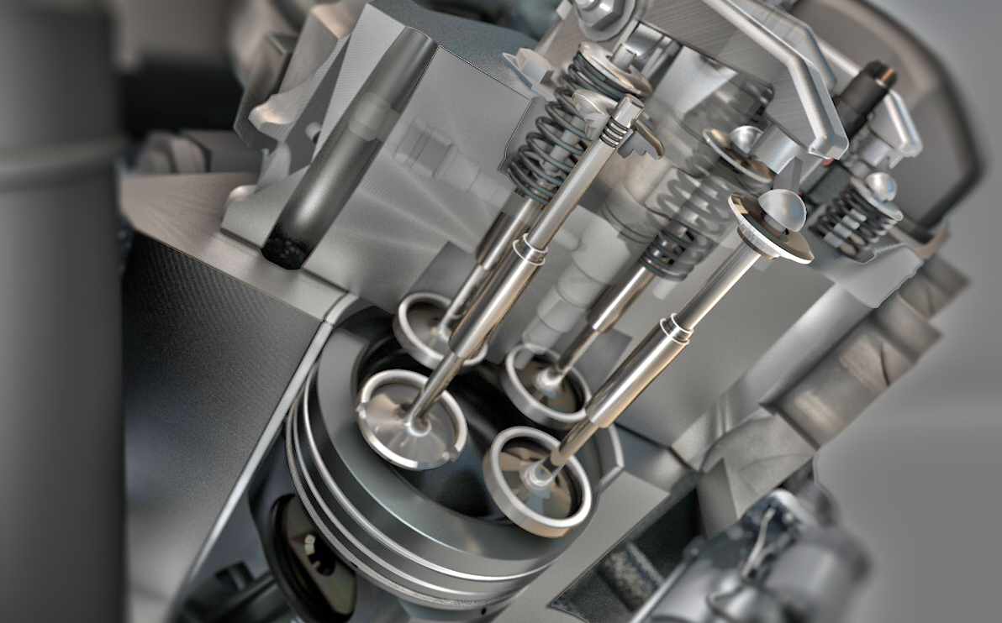 | New materials for inlet and exhaust valves from Federal-Mogul Powertrain are enabling the latest heavy-duty diesel engines to meet the challenges of higher loads, increased corrosion risk and continued downward cost pressure.

