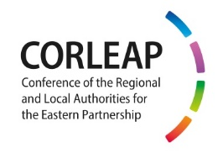 |  | 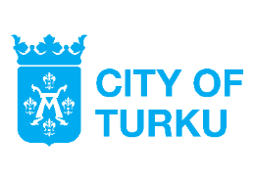

9th annual meeting of the Conference of the Regional and Local Authorities

for the Eastern Partnership (CORLEAP)

Turku, 12 September 2019

AGENDA

Venue | Logomo centre - Logomo Hall 1 (Köydenpunojankatu 14, 20100 Turku, Finland)
Interpretation | English/French/Finnish/Polish/Russian

Please note the meeting is starting at 09:30

09:30–13:00 | CORLEAP ANNUAL MEETING
09:30–10:15 | - Introductory remarks  Karl-Heinz Lambertz, CoR President, Co-Chair  Emin Yeritsyan, President of the Union of Communities of Armenia, Co-Chair  Amb. Matti Anttonen, Permanent State Secretary, Ministry for Foreign Affairs of Finland  Ilkka Kanerva, MP, Chair of the Board of the Regional Council of Southwest Finland  Adoption of the revised CORLEAP Rules of Procedure
10:15–10:30 | Coffee break
10:30–11:15 | - Promoting people-to-people contacts through cross-border cooperation programmes  Pavel Branda (CZ/ECR), Deputy Mayor of Rádlo Municipality, CORLEAP rapporteur  Anders Knape, President of the Congress of Local and Regional Authorities, Council of Europe  Yurii Krivorotko, Lev Sapieha Foundation, Belarus, representative of the Eastern Partnership Civil Society Forum  Discussion and adoption
11:15–12:00 | - Capacity building of local and regional public administration  Sergii Chernov (Ukraine), Chairman of Kharkiv Regional Council, President of the Ukrainian Association of Local and Regional Authorities, CORLEAP rapporteur  Sylwia Ojdym, Deputy Director, Lech Kaczyński National School of Public Administration, Warsaw  Sampo Suihko, Director, Joint Authority of Education in Espoo Region (OMNIA)  Discussion and adoption
12:00–12:45 | - Local and regional authorities shaping the future of the Eastern Partnership  Amb. Anna Westerholm, Ambassador for the Eastern Partnership, Ministry of Foreign Affairs of Sweden  Lawrence Meredith, Director for Neighbourhood East, DG Neighbourhood and Enlargement Negotiations of the European Commission (tbc)  Audrone Perkauskiene, Head of Division for the Eastern Partnership, Regional Cooperation and OSCE, European External Action Service  Tadeuš Andžejevski (LT/ECR), CoR Rapporteur-General on "Local and regional authorities shaping the future EaP"  Discussion
12:45–13:00 | - Information about upcoming CORLEAP activities and  closing remarks by Co-Chairs
13:00–14:00 | Lunch

Omnia is a multisector education provider and regional development center. They offer innovative learning environments and beneficial partnerships both in national and international education development projects.

