Yes Full Circle’s Proteco division unveils pioneering integrated brand protection and zero waste facility in Dubai
Yes Full Circle’s Proteco division officially launched a pilot plug and play facility that provides integrated brand protection, secure destruction and closed loop/zero landfill recycling solutions.

The facility uses proprietary technology to provide full traceability to confirm and validate the entire destruction and recycling process (a global first). The audit trail is stored on Green Secure, a secure blockchain platform, enabling traceability from point of collection to final end point of material post destruction.

The launch event was attended by H.E. Low Pit Chen, Consul-General , Singapore Consulate-General in Dubai, along with a host of distinguished guests from the industry, business partners and media. Harbinder Singh and team welcomed the Consul General and other guests, who were given a tour of the innovative recycling facility, which leverages decades of international and practical experience in recycling, security and technology to offer end of life product/inventory management for businesses and government entities across sectors.

It is the only facility of its kind in the United Arab Emirates (UAE) with 7 different technologies that are designed to process a variety of materials ranging from consumer to industrial goods to counterfeit and confiscated goods. In addition, it is a unique service with the capability to provide both onsite and offsite brand protection/destruction services; and is capable of same day live stream destruction.

The second phase of the facility involves the use of extended digitisation, AI and robotics, resulting in further game changing innovation, both upstream and downstream.

The facility is the first of 9 more facilities to be launched across the Middle East, including 3 in the UAE alone. A significantly larger circular economy/closed loop facility is expected to be operational in the first quarter of 2021.

H.E. Low Pit Chen, Singapore ‘s Consul-General commented: “It was indeed an eye opener for me to see first-hand the innovative solutions offered at Yes Full Circle Solutions. It plays an important role in promoting the concept of circular economy in the UAE and the region. I am happy to learn of its expansion plans which would spread the message of sustainability to more countries and people. I also see opportunities for Singapore enterprises in the environment space to collaborate with partners such as Proteco in introducing innovative solutions to this region.”

Harbinder Singh, Chairman of Yes Full Circle, said: “We are honoured by the presence of Singapore’s Consul- General H.E. Low Pit Chen whose message of cooperation and exchange of best practices between Singapore and the UAE epitomises the spirit of Yes Full Circle and its associate companies that operate across the world. We are proud to promote an honest and transparent brand of recycling in the UAE that puts brand protection, combined with a circular economy and zero landfill as its priority. We look forward to working with clients who share the same values and ethics.”

Yes Full Circle (YFC) is a Singapore based company with regional offices in Singapore, India and United Arab Emirates. Backed by Singaporean investors and family offices, YFC leverages its experience and technology to roll out unique, game changing, sustainable circular economy solutions. In Dubai, YFC’s Proteco division provides zero landfill brand protection services. In India, it has begun the rollout of tech platforms supporting circular economy ecosystem development across 4 cities in 2 states in a phased manner. For more information, visit www.yesfullcircle.com or contact us at singapore@yesfullcircle.com or info@yesfullcircle.com

For media queries , please contact media@yesfullcircle.com or swaliha@mediafusionme.com

- ENDS -

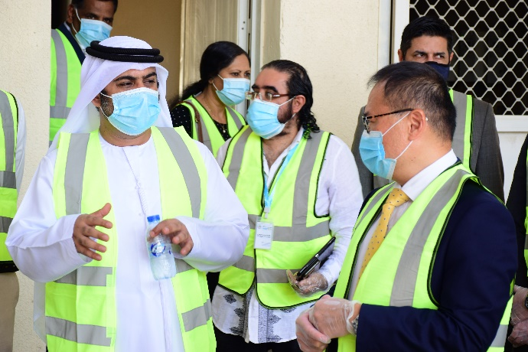
Photo caption: Consul-General of Singapore at the YFC’s Pilot Proteco facility in Dubai.

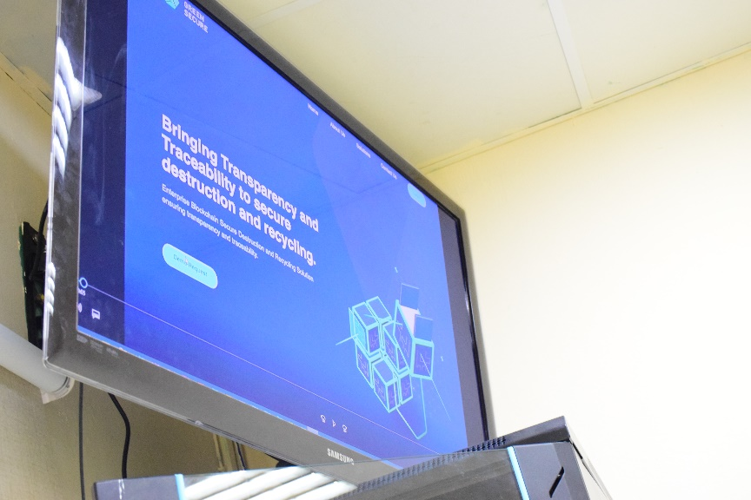

Photo caption: Green Secure

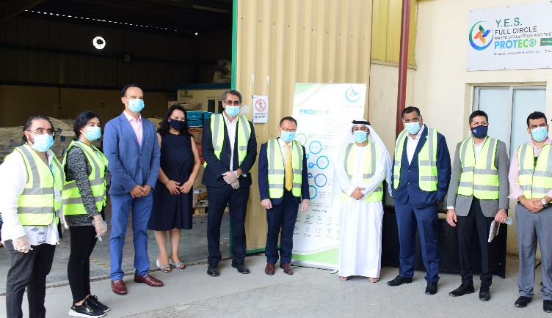

Photo caption: Consul-General of Singapore with members of YFC board and advisors
-----------------------------------

