Samsung 2018 TV-lineup
at First Look Event in New York

The 2018 TV line-up from Samsung is focusing on the three pillars; Picture Quality, Style and Smart. Below is a summary on the news from the Global Launch and a short description of the line-up, model by model.

Summary on the focus for 2018 TV-lineup;

Picture Quality
Among the Picture Quality innovations, we find a new QLED panel construction, with direct full array backlight with a sophisticated carbon mesh for improved light control, and a wide-angle lens system to allow a very slim cabinet in combination with excellent viewing angles.

Style
Samsung presents the Ambient Mode, and the full integration of power and signals in the new One Invisible Connection cable between the screen and the One Connect box.

Smart
Samsung will introduce a new app that will combine the separate apps Smart View, Smart Home and Samsung Connect, into a new Samsung Smart Things App. The set-up process is also simplified by making it possible to use your smart phone for most if the installation. Including the login to your favorite streaming apps.

Short descriptions of the line-up, model by model:

NU7105 & NU7305
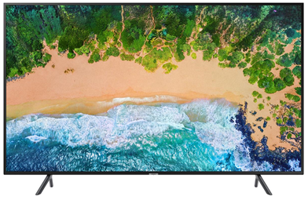
The first model in our 2018 lineup, NU7105, is already a Tizen SMART TV with true certified UHD resolution. It also supports High Dynamic Range, including HDR10, HLG and the dynamic format HDR10+. On top of that, it has a slim, brushed cabinet with a very clever Cable Management arrangement on the backside. It is also available in a curved version, under the name of NU7305.

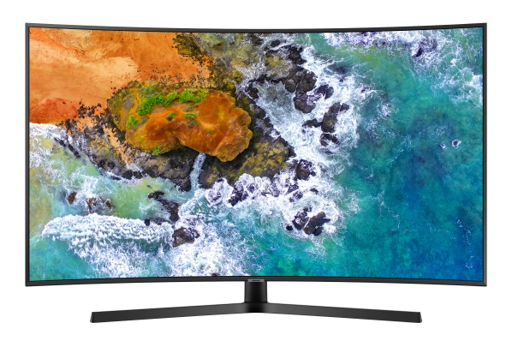
NU7405 & NU7505
This is our step-up UHD-TV, and it comes with a number of smart Samsung benefits. Thanks to Dynamic Crystal Color it has a wider color range than 7105. But most noticeable, it comes with Bluetooth built in. This gives it a number of benefits – including the much appreciated Samsung Smart Remote control. This can be used also connected devices such as set-top boxes that are connected via HDMI. This year, we will also make installation even easier, so you can use your mobile to log in to your streaming apps. It also gives you BT audio features such as TV sound to mobile (to use your mobile phone as wireless headphones), and the possibility to connect soundbars with Bluetooth. From the NU7405 and up, you will also have built in satellite tuner, and the possibility to record TV to USB, we call this PVR. There is also a curved version of this model, called NU7505.

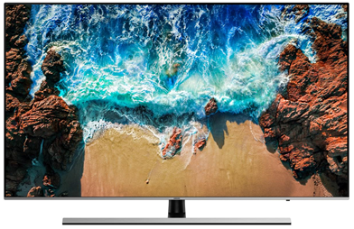
NU8005 & NU8505
With NU8005 we step up to our Premium UHD range. It starts with a premium design where three of the sides have no visible frame the cover the glass. It is also very slim with a brushed hairline finish. It has a more advanced panel with higher frame rate giving it better motion sharpness (55” inch and higher). It also uses ultra slim array dimming backlight to enhance the contrast. The viewing angle has also been improved so that you can view it from the corner of the sofa, and still have great picture. From NU8005 we have also introduced an advanced automatic game-mode that will recognize the game console it is connected to and adapt the picture response. From NU8005 and up, you also get a twin tuner and an additional HDMI input (4 in total). Also the NU8005 has a curved sibling; the beautiful NU8505.

2018 Q7F
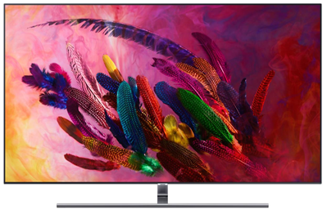
This is where we step in to the second generation of QLED TVs, and this means another big step in our range. You will recognize some familiar QLED specs like Q Color with 100% color volume, and Q Contrast with 1500 nits peak brightness. The Ultra Black coating reduces reflections to a minimum and this year we have improved the Q Viewing Angle even further. But I think that two of the most attractive new features are linked to Q Style. The first is the One Invisible Connection. This year we have managed to integrate the power supply in to the transparent cable that runs from the One Connect box and to the TV itself. This makes it possible to achieve a very clean TV installation. Combine it with the No-Gap wallmount, and it is gorgeous! To make it possible to enjoy your QLED TV also when you are not watching TV, we have added Ambient Mode. With this feature you can fill the screen with the pattern of the wall behind it and combine it with some handy time or weather information. This has to be seen to be believed!

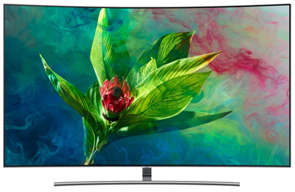
2018 Q8F & Q8C
These are the even more stylish design versions of QLED TV. Take the brilliant Q7 specs and add the beautiful Metal One Control remote, and a brushed layer of metal-paint on the cabinet, and you get these stunning TV’s. The Flat version Q8FN has a Tri-Stand with a new foot, and there is also an elegantly curved version called Q8CN.

2018 Q9F
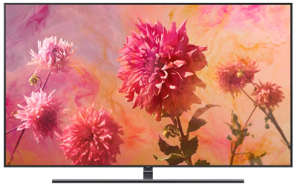
And now we have reached the pinnacle of our range for this spring – the all-new 2018 Q9FN. This model has almost the same slim, sleek cabinet from last year, but now combined with a completely new backlight system. It uses a carbon mesh to prevent light from leaking to pixels where it should not be, and a direct full array backlight with wide-angle lenses to allow a super-thin construction. It also gives us a viewing angle benefit, and whopping 2000 nit peak brightness. The blacks are deeper, and the colors are brighter than ever before. A mesmerizing viewing experience! This set also packs a powerful 60W audio arrangement, with 2 tweeters, 2 widerange units, and 2 woofers. (But if you really want to go all-in, you should of course opt for one of our great soundbars!).

